SPLENDID PUGLIA
13 – 20 May, 2023
Private Group with Linda Bell

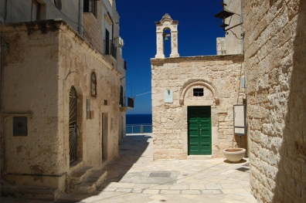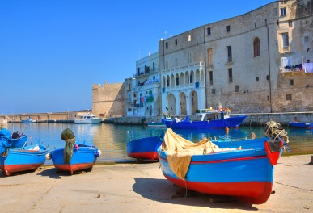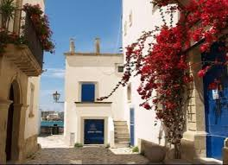
A journey of exploration, warm locals, art and tradition, food and wine, authentic Puglia atmosphere. Benvenuti in Puglia, welcome to the heel of Italy, the country’s least-exploited tourist destination, which has been conquered by just about everyone, from the Byzantine Greeks to the Romans, the Arabs and the Bourbons.
Hundreds of miles of golden beaches with azure water, a breathtaking combination of whitewashed hilltop villages and the Baroque beauty of cities such as Lecce. Plus some of the cheapest, simplest and tastiest food in Italy.
Lecce is one of the most beautiful Baroque city in Italy and it is located near amazing beaches with crystal clear waters on both the Adriatic and Ioanian Seas.
During this trip, in a well -balanced blend of culture and lifestyle, you’ll explore the diverse artistic and architectural styles of Puglia.
Puglia’s architecture is a mish-mash of cultural influences in such a simple way that’s unpretentious, easy, and eminently Salentino.
Puglia has a microclimate that ensures sunny weather for much of the year. Il solleone in summer, the so-called lion sun, and a fertile land allow Puglia to grow intensely flavored olives, fruit and vegetables in abundance. Thus, it produces much of Europe’s pasta, presses most of Italy’s olive oil, catches the bulk of the country’s fish and makes plenty of good, strong wine – enough, in fact, to be the sixth biggest wine making region in the world!
Bread, oil and wine are the central forces in the Puglia diet. It is the place of the so called Cucina Povera (the cuisine of poverty) and it is certainly true that this poor area has made the very best of its local produce. Pasta made without eggs, bread made from the local vegetables, and more make the area a true mecca for the wine and olive oil production. There are no rules; recipes have long been improvised from what is available.
Cucina Povera is probably one of the most delicious, environmental and conscious way of eating based on affordable ingredients or whatever is on hand in the farm and in the kitchen. Inspired by local seasonal ingredients, a mix of cereals, vegetables and legumes this diet has been emulated by many world-wide.
Puglia is the ideal backdrop for a relaxing experience and a rustic-chic holiday to remember.
Discover Puglia’s many small towns and villages, a treasure trove of lifestyle art, architecture, history, design and culture. Traditional farmhouses have been restored and converted into fabulous, small boutique hotels – these are the Masserias of Puglia! We will be starting our lovely week in a luxurious Masseria! Simply relax and soak in Puglia’s simple, laidback way of life. Enjoy the landscape, the food, and the warm hospitality of the locals.

WHY PUGLIA IN YOUR BUCKET LIST?
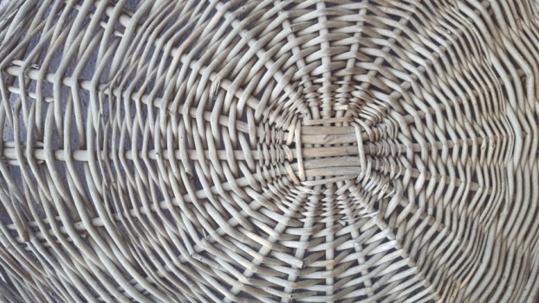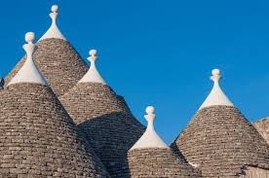

- It is a gem of the south of Italy
- It is authentic
- The food and wine are incredible #cucinapovera #26DOCwines
- It’s a land of vivid colors and rustic charm dotted with pretty seaside towns
- It’s design, white, colorful, simple, unique
- It creates lifelong memories
- Lecce is sumptuous
- The Trulli valley is like a fairytale
- The Salento is pure poetical beauty

This trip has been designed to immerse in the local culture. Every day you’ll explore a part of the region and discover its incredible beauty: architecture, sacred sites, characteristic historic towns, food and wine, locals. Yet you’ll have plenty of free time to relax and explore on your own and enjoy the unique indigenous lifestyle.
In this itinerary, we have included the very best of Puglia, through places where you can truly get the real feel of the region, staying in lovely places and exploring with expert local guides.
There’s an austere beauty to Puglia. A holiday in Puglia is a great pleasure. It’s a magic puzzle of beauties where you get lost. It is that special beauty that makes it clear that you are absolutely nowhere else.

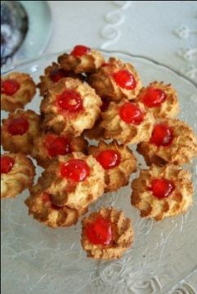 YOUR ITINERARY
DOLCE VITA IN PUGLIA
MAY 13 - ARRIVAL DAY MASSERIA
arrive Brindisi airport and transfer to Masseria ****
check in and relax by the pool
(for early arrive light brunch lunch time)
pre-dinner introduction of the trip with Linda's local hosts and glass of wine
welcome dinner at the Masseria

MAY 14 CASTRO MARINA + OTRANTO
After breakfast, leisure time by the pool
Transfer to a winery located in the north of Salento for lunch
Afternoon cultural tour of Otranto and free time
return to the Masseria around 5/pm and relax time
dinner at the Masseria 8 pm

extra activities we can arrange this morning at the masseria not included in the price: hiking and/or biking with a guide, deep tissue massages, yoga sessions
Bikes are for rental and we suggest having a guide with them who knows how to tour around the area
MAY 15 GALLIPOLI + GALATINA
After breakfast, excursions to the charming southern towns of Gallipoli and Galatina with lunch.
Explore Gallipoli, the town of fishermen and Mediterranean flair and enjoy lunch savouring the traditional cuisine.
Galatina is the elegant little town of Salento with its magnificent Basilica of Santa Caterina d'Alessandria scattered with Frescoes of the Romanic Gothic Art in Puglia.
Return to the masseria around 4/6 pm
relax time and dinner at the masseria 8 pm
Departure time is 10:00 am
MAY 16 CHEESE/OLIVE OIL EXPERIENCE + LECCE
Check out from the Masseria and welcome to the city of Barocco.
On the way we will stop at a local farm for a cheese and olive oil tasting experience.
Arrive in Lecce, check in and light lunch in Lecce old town.
After lunch, guided walking tour of Lecce and free time.
Private visit and tea at an Aristocratic Palace in Lecce old town.
Dinner in the old town Trattoria style sampling the cucina povera leccese.
departure times from Masseria 10:00 am
and arrival time in Lecce 12:30.
Approximate length of visit @ cheese/olive oil farm (1h30)

MAY 17 OSTUNI + POLIGNANO A MARE
Excursions to the little towns of Ostuni and Polignano a Mare. We will call this day "photo walks" capturing the beauty of the white washed stone villages of Puglia with tiny houses, and bloomed balconies.
Lunch will feature the food specialties of central Puglia.
Return to Lecce mid -afternoon and free time
Dinner at leisure
Departure 9.30 am
and return times 5-6 pm
MAY 18 ALBEROBELLO + CISTERNINO
Excursions to the fairytales towns of Alberobello and Cisternino.
Only in Alberobello you will see so many Trulli houses!
Lunch will feature the special foods of the Itria Valley simple cuisine.
Return to Lecce mid-afternoon and free time.
Dinner at leisure.
departure and return times 9:30 am
return times 5-6 pm

MAY 19 COOKINPUGLIA EXPERIENCE
Grab your apron today!! It's cooking class with the mums of COOKINPUGLIA.
A dolce vita day Italian style with food, wine and local dancing!
Return to Lecce after lunch and free time.
Pop up wine bar in Lecce for happy hour!
Dinner on leisure.
departure 10:15
and return times @ 3:30 pm
MAY 20 DEPARTURE DAY
Arrivederci Puglia!
Private transfers to Brindisi airport

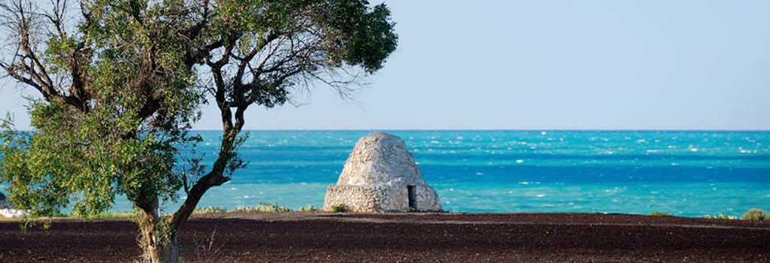

INCLUSIONS
3 nights at Masseria ****Masseria Chicco Rizzo
4 nights in Lecce **** Hotel Santa Chiarra
wine and tips included in all meals
3 dinners at the masseria buffet Salento style at 8 pm (flexible we can ask for a different time if required for your group)
1 dinner in Lecce (check in day)
1 pop up wine bar in Lecce
1 tea/coffee private visit of the Aristocratic Palace
3 dinners on own
all lunches
Group transportation from arrival to departure
Bilingual hosts + private guides
1 welcome dinner Trattoria Style “Benvenuti a Lecce Città del Barocco”
1 cooking class
1 winery experience with lunch
1 cheese/olive oil experience with tastings
excursions as per program featuring lovely restaurants for lunch

optional extras: we can arrange for you anything you would like during your leisure time – yoga, biking, hiking, horseback riding, sailing, massages…prices not included but can make all arrangements for your pleasure

We highly recommend travel insurance to assist you in the event of medical emergency, lost baggage, cancelled trip or any other trip related issue.

We reserve the right to make modifications and to make substitutions to the itinerary as necessary to improve the trip quality or to accommodate the comfort, convenience and wellbeing of the travelers. In this event we will always substitute an equal or better option.
dates: May 13 - 20, 2023

Cost per person:
in double sharing - $4500
single supplement - $1000

Optional EXTRAS: yoga, massages, bike tour, hiking

A non-refundable $1000.00 deposit per person is required to hold your space.
Full payment must be received 60 days prior to departure.

